Delete Before Submitting: At the end of the template is a style table that can be used to copy the format using the format painter as an option for those unfamiliar in the use Styles in MS Word.
The below is a suggestion. However, the abstract and Keywords are required.
Additional information can be found in the Template instructions

Title

Author¹, Co-Author Name², Co-Author Name³
¹Company Name, Location
²Company Name, Location
³Company Name, Location
¹Email: joe@joescompany.com
²Email: sarah@sarahscompany.com
³Email: amy@amyscompany.net

ABSTRACT (max 150 words)

KEYWORDS

INTRODUCTION | BACKGROUND

METHODOLOY

RESULTS

DISCUSSION

CONCLUSIONS

REFERENCES

DELETE BEFORE SUBMITTING:
Formatting Help:
If you are not familiar with the use of styles you can use the format painter to format the document by applying the styles.
Step 1: write your paper and don’t worry about formatting
Step 1: use the Format Painter to copy the format (apply styles). Double click if you want to apply a format to multiple section.
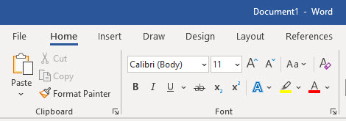

Style | Format Painter Source
Heading | Example Text
Sub-Heading | Example Text
Caption | Example Text
Body Text | Example Text
List Bullet | - Example Text  - Example Text
Numbered List | - Example Text  - Example Text
Author | Example Text
References | Example Text Example Text Example Text Example Text

