Use this sample abstract for content guidance only and not formatting. Follow the formatting instructions provided in the submission site.
Guidelines, Tools, and Case Studies for Optimizing Nutrient Removal Performance

Assistant Facilitator(s): Michael Falk (HDR Inc); Eric Evans (HDR Inc.)
Facilitator: J Neethling
Session Speaker(s): J Neethling ; Michael Falk (HDR Inc); Oliver Schraa (inCTRL); Andrew Shaw (Black & Veatch); Bryce Figdore (AECOM); AECOMl Sreerama Murthy Kasi (Smith & Loveless Inc); Michelle Hetherington (Orange County Sanitation District; Erika Bailey (City of Raleigh); John Buchanan (University of Tennessee)

ABSTRACT:
GOAL
This session will present the findings and outcome from the Water Research Foundation project WRF 4973 Guidelines for Optimizing Nutrient Removal Plant Performance. The objective for WRF 4973 project is to investigate approaches used to optimize existing WRRFs for nutrient removal, utilize full scale examples of how it is done, and to produce a guide on how to optimize WRRFs for nutrient management.

The goal of this session is that the participants learn different optimization approaches, understand how to optimize a WRRF to reduce nutrient discharged from a WRRF, and/or reduce the cost to operate the nutrient removal WRRF. Participants will gain a first-hand look at the tools developed in WRF 4973 for nutrient reduction including decision trees, fact sheets, and other tools. This session will benefit managers, engineers, operators, maintenance personnel who want to improve WRRF nutrient optimization.

The session will address questions such as:
* How can I reduce nutrient discharges from a WRRF that provides secondary treatment (cBOD mode).
* How can I improve the nutrient removal in a conventional nutrient removal (CNR) WRRF?
* How can I reduce the operating cost in a CNR nutrient removal WRRF?
* How can I improve phosphorus removal reliability in a tertiary nutrient removal (TNR) WRRF?
See Figure 1 for description for CNR, TNR, and advanced nutrient removal (ANR).

DRIVERS TO OPTIMIZE WRRF FOR NUTRIENT REMOVAL

Many utilities face a requirement to reduce nutrient discharges into receiving waters. Utilities with nutrient removal requirements in permits are facing more stringent nutrient discharge requirements, which will also require more reliable treatment (e.g., Florida, Virginia, New York, Connecticut, Missouri, Minnesota, Iowa, Colorado, California, and others). In many cases, the first requirement applied to WRRFs is a nutrient optimization step.

Other WRRFs have no nutrient discharge limits but are considering future nutrient load caps that entail an initial step of optimizing WRRFs for nutrient management (two examples are Puget Sound in Washington State and San Francisco Bay in Northern California).

Optimizing a WRRF for nutrient management includes the following three overall objectives as defined under WRF 4973:
* Reduce the WRRF operating cost
* Reduce the WRRF nutrient discharge– this has two subcategories: reducing nutrients discharged from a secondary (BOD only) WRRF or further reducing nutrient discharges from a WRRF that is already doing nutrient removal.
* Improving the performance reliability for a WRRF already doing nutrient removal.

GUIDANCE / DECISION TREE APPROACH TO OPTIMIZATION

The focus in this session is on WRF 4973 guidance document, decision trees, and supporting material to identify strategies that can be used to optimize a WRRF. A collection with 36 decision trees for optimization is shown in Figure 2 through a step-wise selection:
• Step 1 - Identify the appropriate nutrient or target for optimization (NH4, TN, TP, or N and P).
• Step 2 - Identify the type of secondary or tertiary process in the existing WRRF. This could be different types of suspended growth, fixed film, tertiary process or natural treatment systems.
• Step 3 – Select the optimization objective(s).
• Step 4 – Compare performance to benchmark facilities. The benchmark is to identify any "opportunities for improvement" compared to similar WRRFs. If there is little room for improvement, then the user may opt to pursue a different optimization objective.
• Step 5 – Review the list of potential solutions. Note: each solution has a corresponding fact sheet that has details for evaluating that particular concept.

The selections in Steps 1, 2, and 3 are used to identify the appropriate decision tree. The example selection in Figure 2 would identify the tree as: "Optimization of CNR WRRF for TN reduction to reduce nutrient discharge." This tree in Figure 3 contains a list of potential strategies that the user can further investigate. Each strategy points to a fact sheet or multiple fact sheets that provide additional information.

Thirty-seven fact sheets were prepared for WRF 4973 divided in 11 strategy themes (see Table 1). Each strategy theme has several fact sheets that builds on each other (see Figure 3 for fact sheets under the strategy theme of Carbon Management). The first level fact sheet covers the strategy theme overall and identify areas to consider. The second level in the theme provides a description of strategies with similar approaches (such as ABAC vs. AvN vs. on-off aeration). The future third and fourth levels could contain more specific information on each specific approach and perhaps specific equipment or proprietary options. References are noted to provide additional information. Future work could further expand the fact sheet details.

These steps will result in a list of strategies that could be considered for implementation. These strategies should be narrowed down to the most appropriate alternatives given the local circumstances. Factors such as available space, capacity needs, temperature, regulatory requirements, cost, and other factors should be considered for final evaluation and eventual implementation.

SESSION FORMAT

We propose 2 general information presentations focusing on the decision tree and then strategies (including the fact sheets) on optimization. WRF 4973 findings and outcomes are the basis for all of the information shared.. Following the presentations, we will have a panel discussion that will also include case study analysis

CONCLUSION

This session will provide unique sharing and learning opportunities from the WRF 4973 team that will focus on optimizing WRRFs for nutrient management with an emphasis on the core project treatment objectives: i) provide nutrient removal at WRRFs that currently provide secondary treatment, ii) improve nutrient reliability at WRRFs already removing nutrients, and iii) reduce costs for WRRFs already removing nutrients.

Three key learning objectives for this session are:
• Participants will identify the fundamentals of nutrient reduction and the focus areas to optimize the process. For example, while conventional thinking is to maintain a DO above 2 mg/L in biological treatment, lower DO's can be used under appropriate conditions to achieve both nitrification and denitrification and lower cost and higher efficiency.
• Participants will identify opportunities for optimizing WRRF operation to reduce operating costs and to improve process performance these two may be mutually exclusive in some instances.

AGENDA (enter into the Agenda portion and not the body of the abstract!)

1:30 PM - 1:35 PM Introduction
1:35 PM - 1:50 PM Decision Trees
1:50 PM - 2:05 PM Optimization Strategies and Fact Sheets
2:05 PM - 2:55 PM Panel Discussion: Guidelines for Optimizing Nutrient Removal Performance
2:55 PM - 3:00 PM Closing

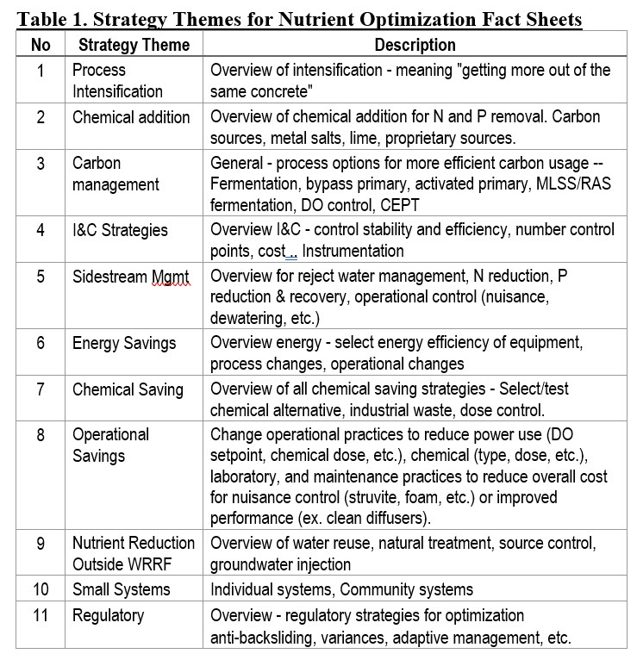
·Strategy Themes for Nutrient Optimization Fact Sheets
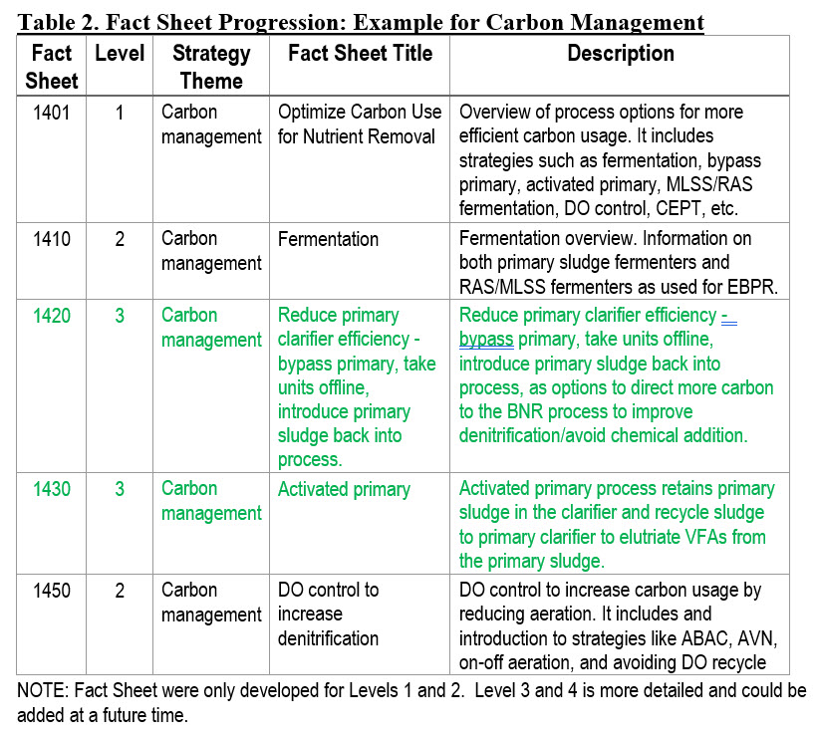
·Fact Sheet Progression: Example for Carbon Management

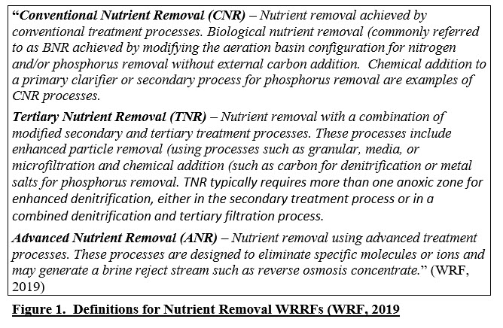
·Definitions for Nutrient Removal WRRFs (WRF, 2019)
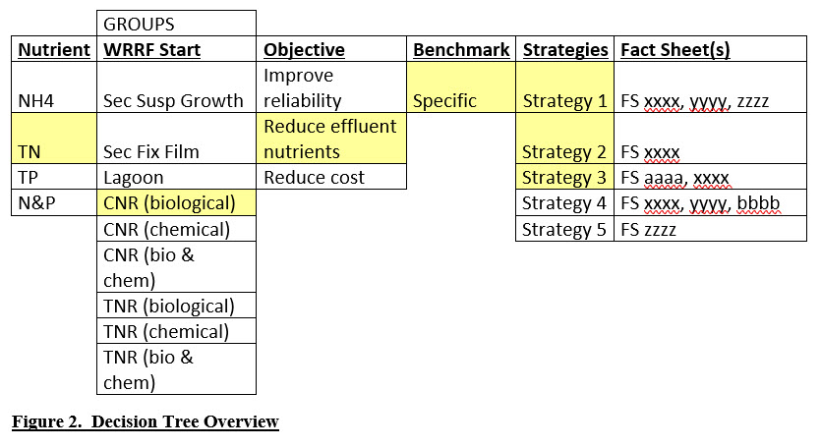
·Decision Tree Overview
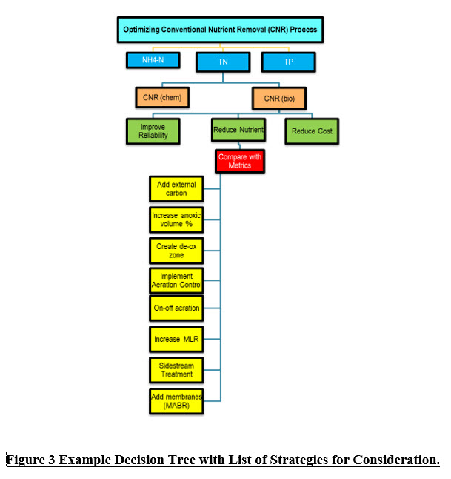
·Example Decision Tree with List of Strategies for Consideration

